# 2A) Planning – Content Map

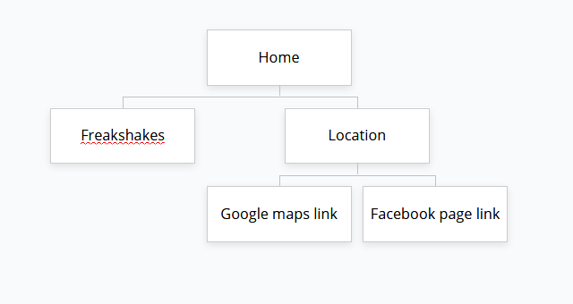

**2A) Planning – Page Sketch**

*2Aiv) Insert, or Paste your rough sketch here.*

# 2F) Publish your site

# 3A) Testing in two browsers

*3A) Test the published website on at least two browsers:*

|  |  |
| --- | --- |
| **What I tested** | **Result** |
| Does webpage work in chrome | Yes |
| Does webpage work in Firefox | yes |
|  |  |

# 3B) Testing Plan (Specifications)

*3B) Test the site against the testing plan*

|  |  |
| --- | --- |
| **What I tested** | **Result** |
| 1. Must attractively *present* B2B colour scheme (“Light sea Green”, or #20B299) | The web page does this |
| 1. Must have three *functional* pages: Home page, Freakshakes page, and another page. | It does |
| 1. Must contain B2B’s location (373 Church Street, PN) and hours (Tue – Sat 7:30am-4:30pm. Sun – Mon 8:30am – 3:30pm) | It does |
| 1. At least one sentence on each page which is clearly *readable* and *legible*. | Yes |
| 1. *Layout* an aside column, which is *formatted* to the right-hand side of all pages. | Yes |
| 1. At least two *Media/images* of their food or drinks on the site. (Images provided) | yes |
| 1. *External Hyperlinks* to [facebook.com/B2BBakeryandCafe/](https://www.facebook.com/B2BBakeryandCafe/) and [B2B’s location on google maps](https://www.google.com/maps/place/B2B+Bakery/@-40.3563407,175.6134476,17z/data=!3m1!4b1!4m5!3m4!1s0x6d41b2da8f1ff159:0x6b1163b053bcd7ea!8m2!3d-40.3563407!4d175.6134476?hl=en). | yes |
|  |  |
|  |  |
|  |  |

# 4A) Evaluation – Target Audience

# 4B) Evaluation - Specifications